**SYSTEM DESIGN DOCUMENT**

For

**Electronic Examination Marking (E-Marker)**

Prepared By

Amal Hamood Al-Jabri: 16J1023

Maryam Said Al-Hashmi: 110S091

Salwa Harib Al-Tobi: 16J09564

Under the guidance of

Mrs. Rounait

Semester II /2014

* 1. **Introduction**

The System Design Document describes the system requirements, operating environment, system and subsystem architecture, files, input formats, output layouts, human-machine interfaces, detailed design, processing logic, and external interfaces. This document will be produced with a brief description of the Electronic Examination Marking system.

* 1. **System Design Overview**

Electronic Examination Marking (E-marker) is an application which allows user to scan exam result sheet and student answer sheets. The application will process the comparison between result sheet and student answer sheets and calculates total mark of the students. The following displays show the structure of E-marker application.

**3.3 Application Design Detail**

**3.3.1 Table Structure**

i. Table Name: Student

|  |  |  |  |  |
| --- | --- | --- | --- | --- |
| **Field Name** | **Data Type** | **Field Size** | **Constraints** | **Description** |
| Student_ID | Varchar2 | 8 | Contain 1 letter | Primary Key |
| Student_Name | Character | 30 | Not Null |  |
| Section | Number | 2 | Not Null |  |
| Total_mark | Number | 3 |  |  |
| Student_ Sheet | Image | 100 |  |  |
| Exam_ID | Number | 4 | Not Null | Foreign Key |
| Teacher_ID | Number | 4 | Not Null | Foreign Key |

ii. Table Name: Teacher

|  |  |  |  |  |
| --- | --- | --- | --- | --- |
| **Field Name** | **Data Type** | **Field Size** | **Constraints** | **Description** |
| Teacher_ID | Number | 4 | Not Null | Primary Key |
| Username | Character | 30 | Not Null |  |
| Password | Number | 10 | Not Null |  |

iii. Table Name: Exam

|  |  |  |  |  |
| --- | --- | --- | --- | --- |
| **Field Name** | **Data Type** | **Field Size** | **Constraints** | **Description** |
| Exam_ID | Number | 4 | Not null | Primary Key |
| Exam_name | Varchar2 | 10 |  |  |
| Exam_Date | Date | 10 | dd-mm-yyyy |  |
| Subject_name | Varchar2 | 20 |  |  |
| Result_Sheet | Image |  |  |  |
| Teacher_ID | Number | 4 | Not Null | Foreign Key |

|  |  |  |
| --- | --- | --- |
| **0NF** | **1NF** | **2NF** |
| Student_ID @  Student_Name  Section  Total_mark  Student_Sheet  ( Exam_ID  Exam_name  Exam_Date  Subject_name  Result_Sheet  Teacher_ID  Username  Password )* | **Student** | **Student** |
| Student_ID @  Student_Name  Section  Total_mark  Student_Sheet  Exam_ID ! | Student ID @  Student Name  Section  Total Result  Student Answer Sheet  Exam ID !  Teacher_ID ! |
| **Teacher** |
| Teacher_ID@  Username  password |
|
|
| **Exam** | **Exam** |
| Exam_ID @  Exam_name  Exam_Date  Subject_name  Result_Sheet  Teacher_ID  Username  password | Exam_ID @  Exam_name  Exam_Date  Subject_name  Result_Sheet  Teacher_ID ! |

**3.3.2 Normalized Table Layouts**

**3.3.3 Data Flow Diagrams**

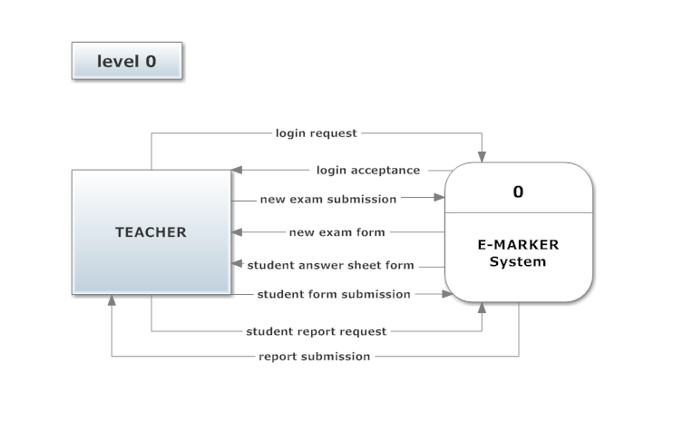

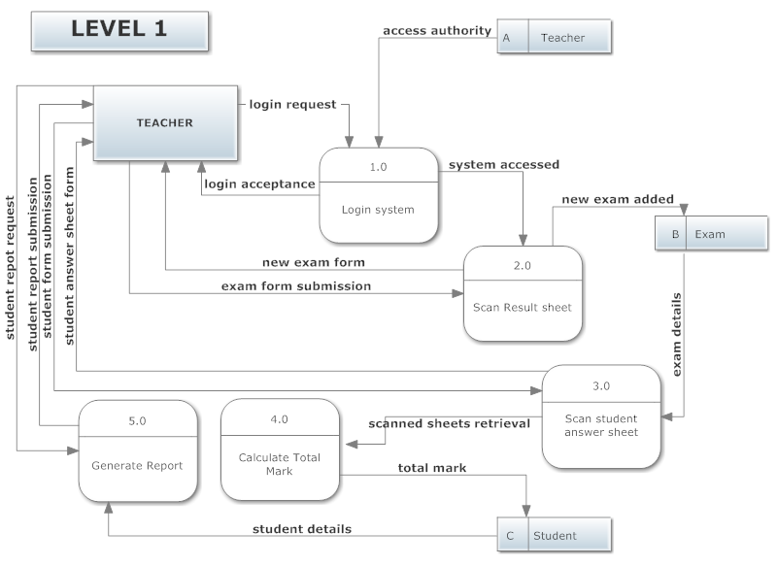

**3.3.4 Entity – Relationships**

